List of all alerts found after scanning :

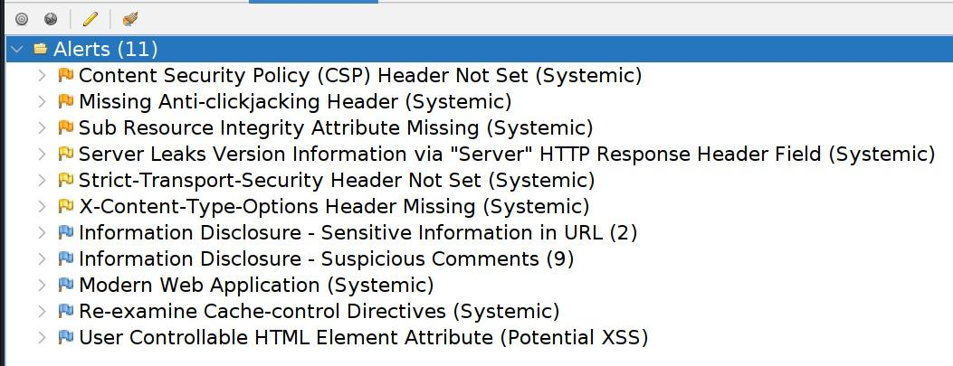

ONE-BY-ONE report for each alert :

1.

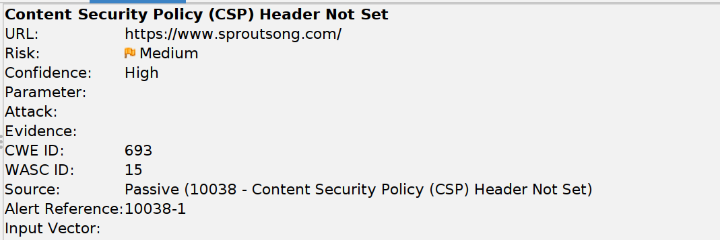
Description:
Content Security Policy (CSP) is an added layer of security that helps to detect and mitigate certain types of attacks, including Cross Site Scripting (XSS) and data injection attacks. These attacks are used for everything from data theft to site defacement or distribution of malware. CSP provides a set of standard HTTP headers that allow website owners to declare approved sources of content that browsers should be allowed to load on that page — covered types are JavaScript, CSS, HTML frames, fonts, images and embeddable objects such as Java applets, ActiveX, audio and video files.
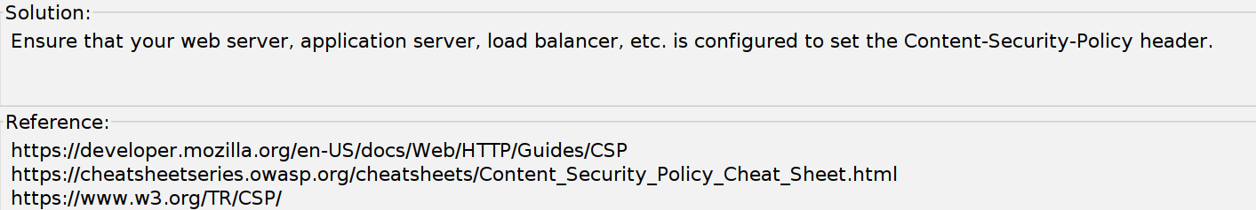

2.
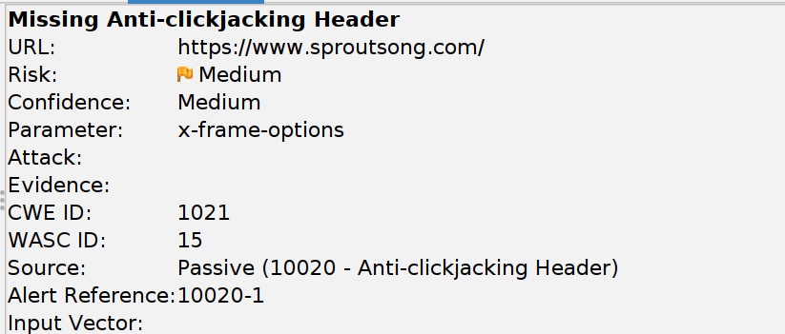
Description:
The response does not protect against 'ClickJacking' attacks. It should include either Content-Security-Policy with 'frame-ancestors' directive or X-Frame-Options.

Solution:
Modern Web browsers support the Content-Security-Policy and X-Frame-Options HTTP headers. Ensure one of them is set on all web pages returned by your site/app.
If you expect the page to be framed only by pages on your server (e.g. it's part of a FRAMESET) then you'll want to use SAMEORIGIN, otherwise if you never expect the page to be framed, you should use DENY. Alternatively consider implementing Content Security Policy's "frame-ancestors" directive.

Reference:
https://developer.mozilla.org/en-US/docs/Web/HTTP/Reference/Headers/X-Frame-Options

3.
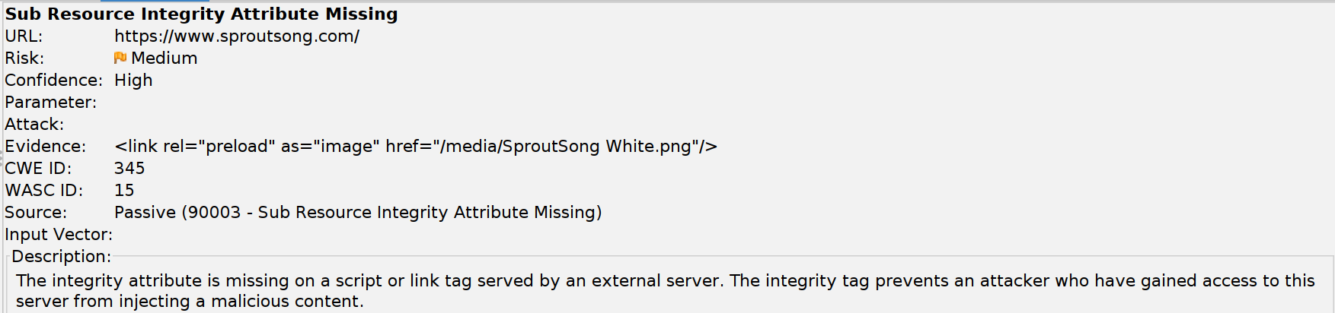
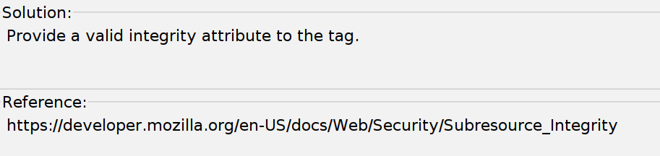

4.
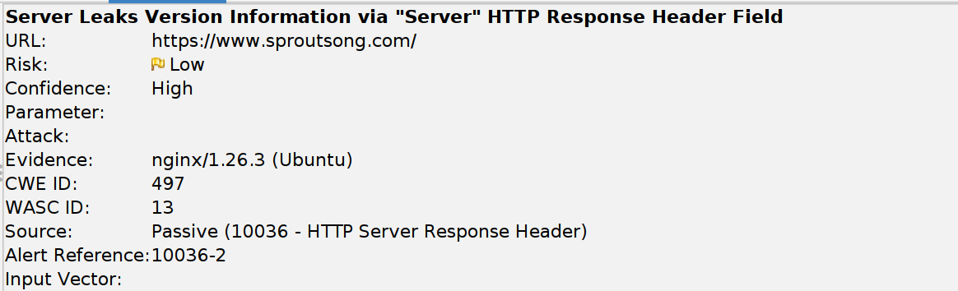
Description:
The web/application server is leaking version information via the "Server" HTTP response header. Access to such information may facilitate attackers identifying other vulnerabilities your web/application server is subject to.

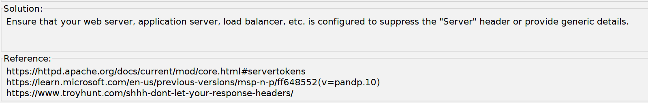

5.
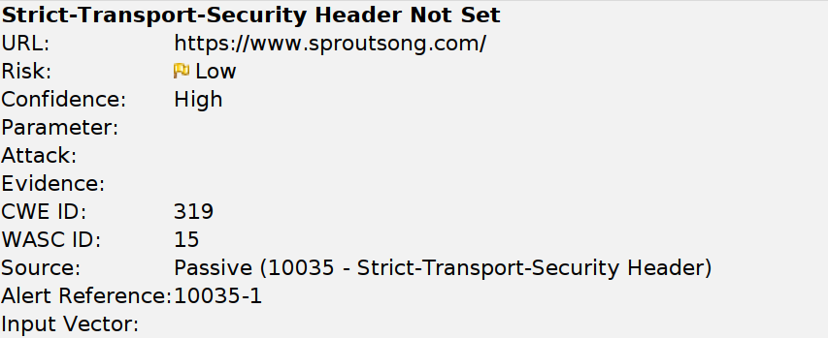

Description:
HTTP Strict Transport Security (HSTS) is a web security policy mechanism whereby a web server declares that complying user agents (such as a web browser) are to interact with it using only secure HTTPS connections (i.e. HTTP layered over TLS/SSL). HSTS is an IETF standards track protocol and is specified in RFC 6797.

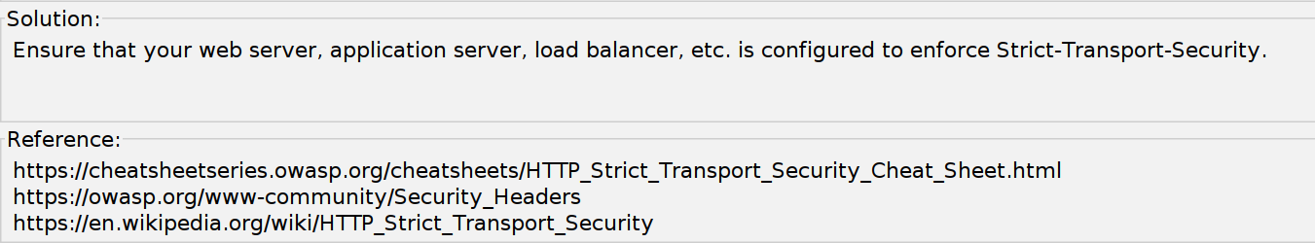

6.
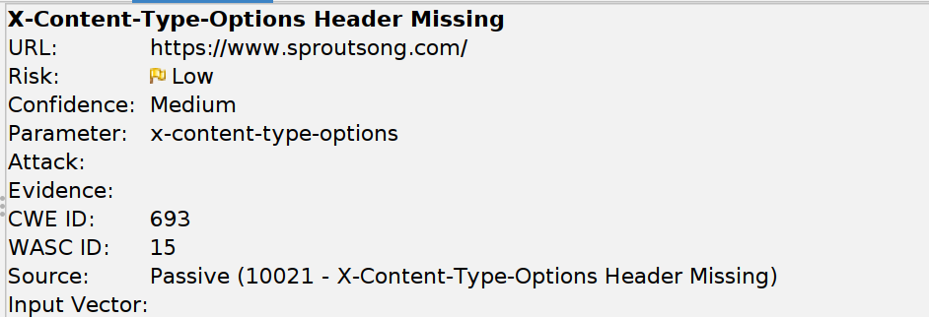

Description:
The Anti-MIME-Sniffing header X-Content-Type-Options was not set to 'nosniff'. This allows older versions of Internet Explorer and Chrome to perform MIME-sniffing on the response body, potentially causing the response body to be interpreted and displayed as a content type other than the declared content type. Current (early 2014) and legacy versions of Firefox will use the declared content type (if one is set), rather than performing MIME-sniffing.

Other info:
This issue still applies to error type pages (401, 403, 500, etc.) as those pages are often still affected by injection issues, in which case there is still concern for browsers sniffing pages away from their actual content type.
At "High" threshold this scan rule will not alert on client or server error responses.

Solution:
Ensure that the application/web server sets the Content-Type header appropriately, and that it sets the X-Content-Type-Options header to 'nosniff' for all web pages.
If possible, ensure that the end user uses a standards-compliant and modern web browser that does not perform MIME-sniffing at all, or that can be directed by the web application/web server to not perform MIME-sniffing.

7.
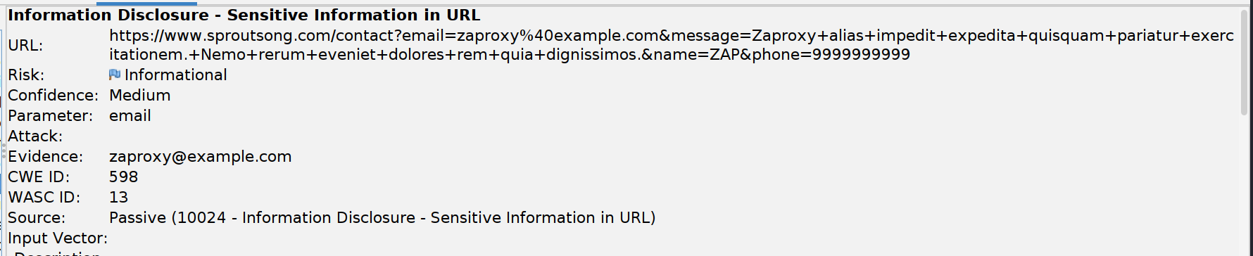

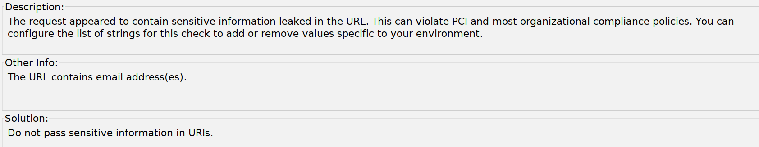

8.
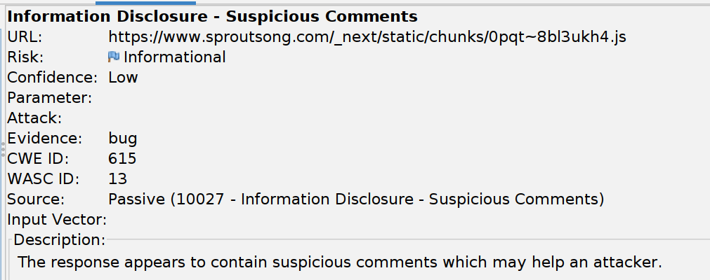

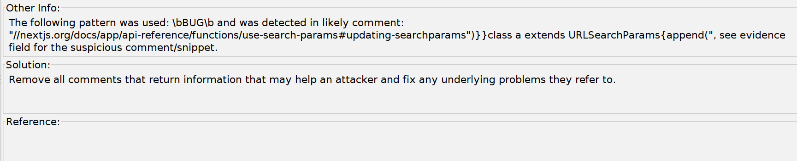

9.
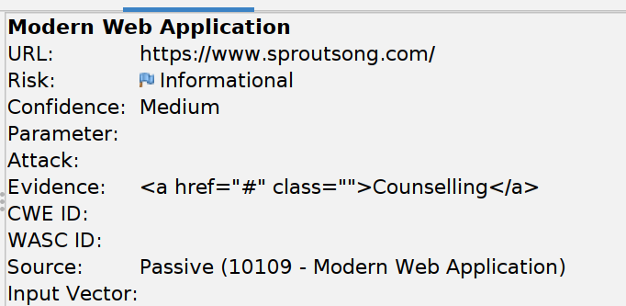

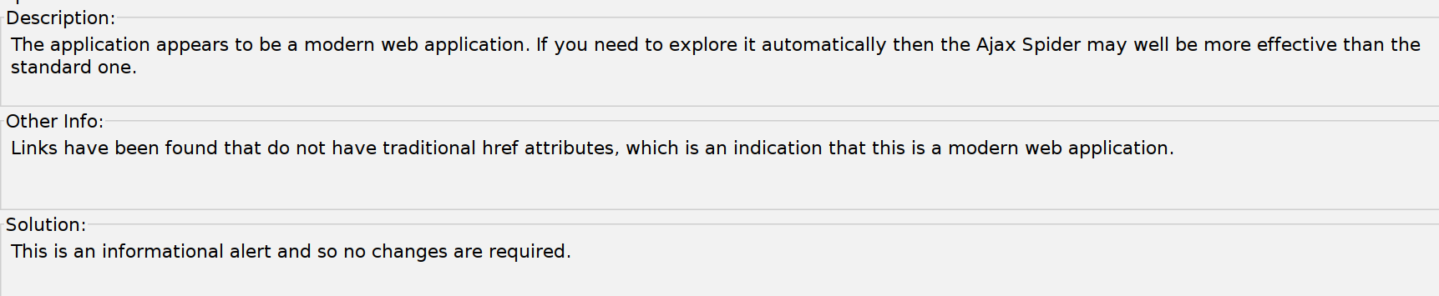

10.
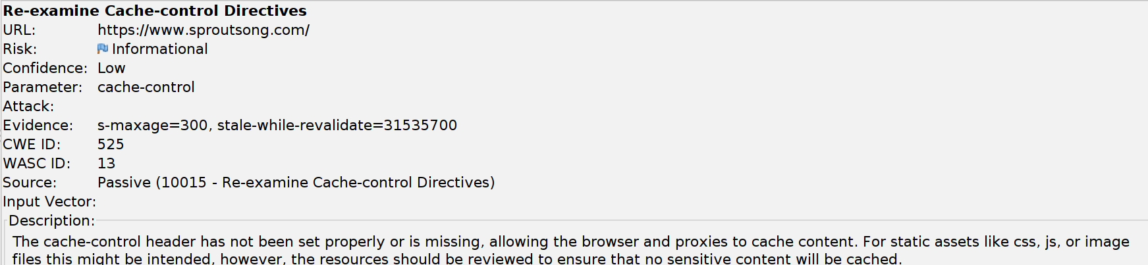

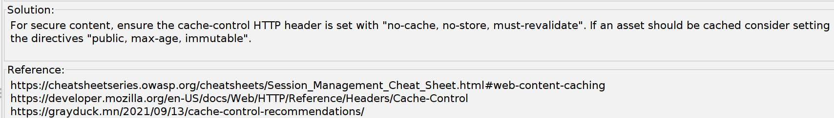

11.
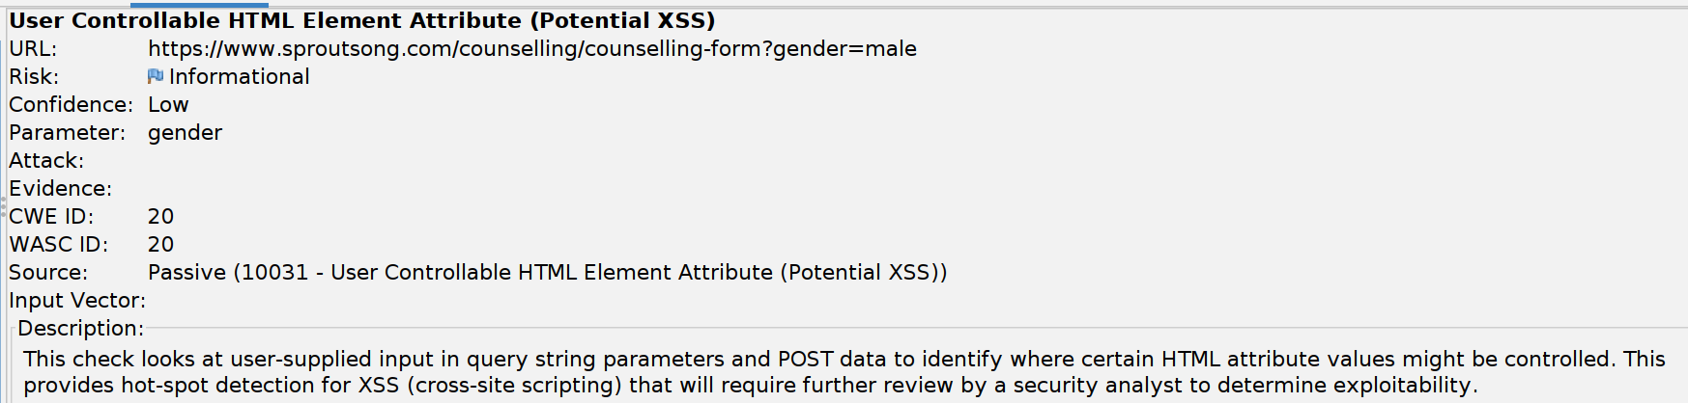

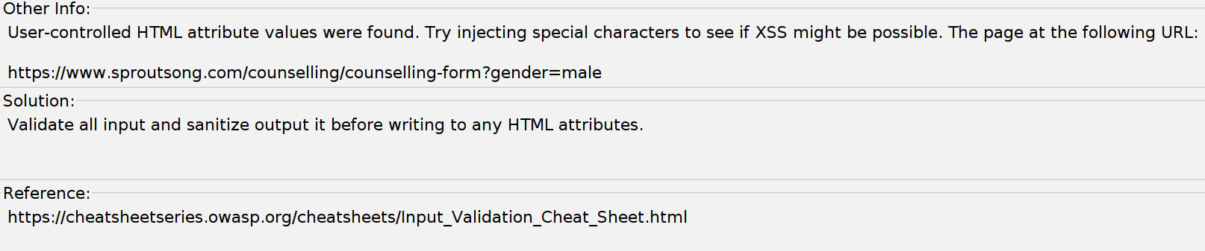

OTHER ALERTS FOUND BY AJAX SPIDER:

What is AJAX Spider? 🤔
Check the URL:- https://share.google/aimode/C9Zt0ECPZFzEHWvjS

1.
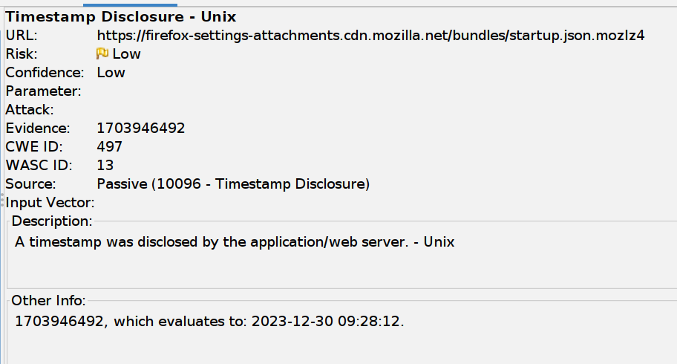
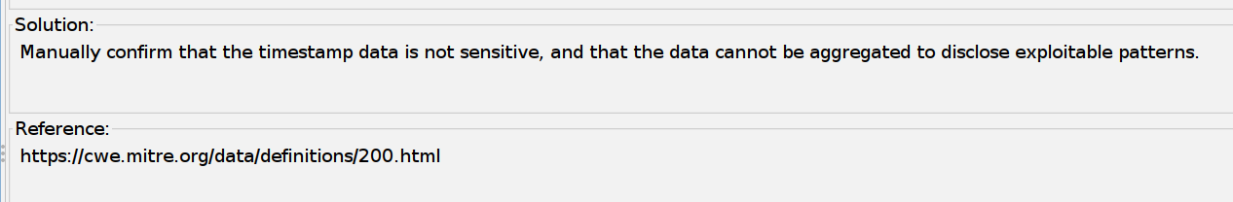
2.
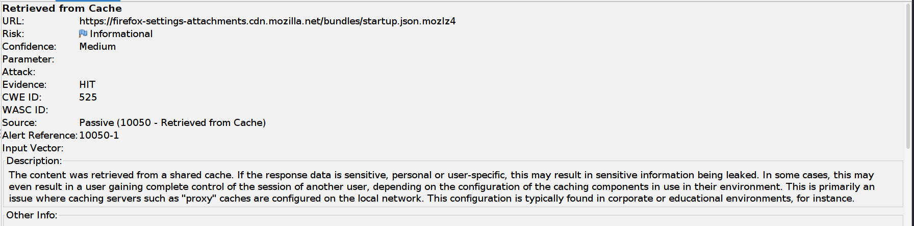

Solution:
Validate that the response does not contain sensitive, personal or user-specific information. If it does, consider the use of the following HTTP response headers, to limit, or prevent the content being stored and retrieved from the cache by another user:
Cache-Control: no-cache, no-store, must-revalidate, private
Pragma: no-cache
Expires: 0
This configuration directs both HTTP 1.0 and HTTP 1.1 compliant caching servers to not store the response, and to not retrieve the response (without validation) from the cache, in response to a similar request.

